JACOB, Christopher Jr, M.

BSIT-2, Block-A

A-IT ELEC 03

**ACTIVITY 2:** SuperGlobals

Home.php

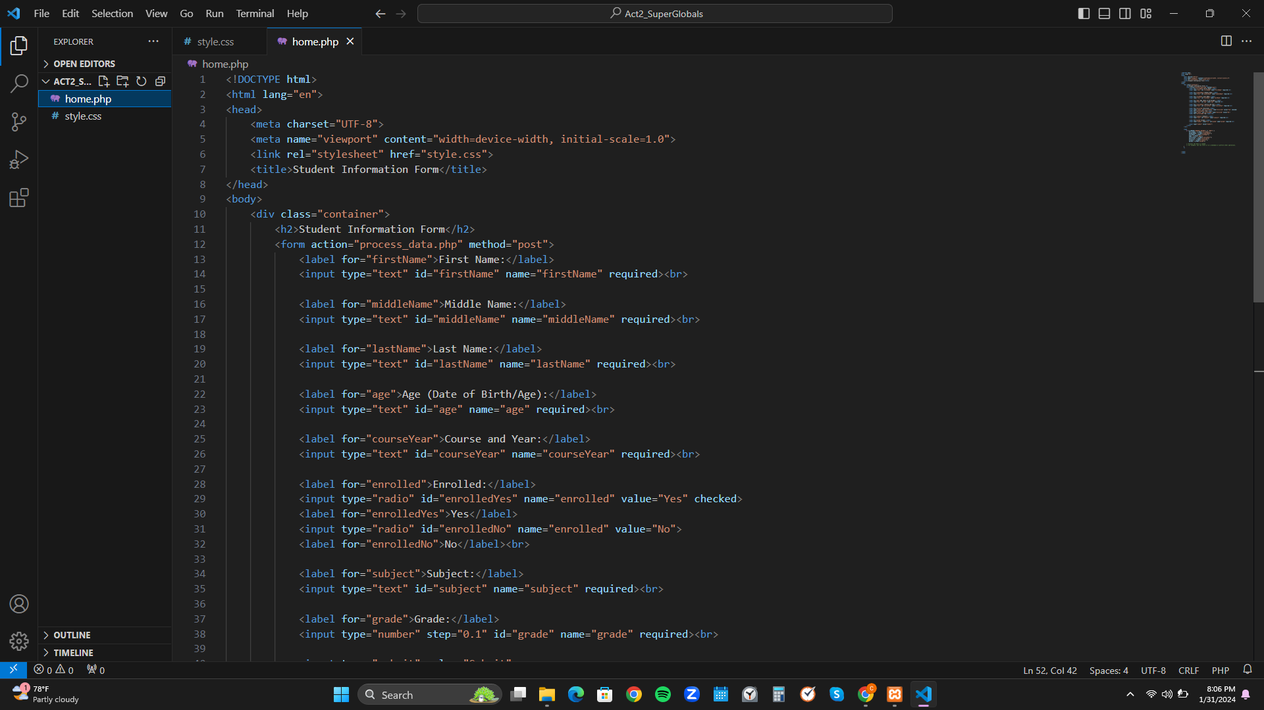

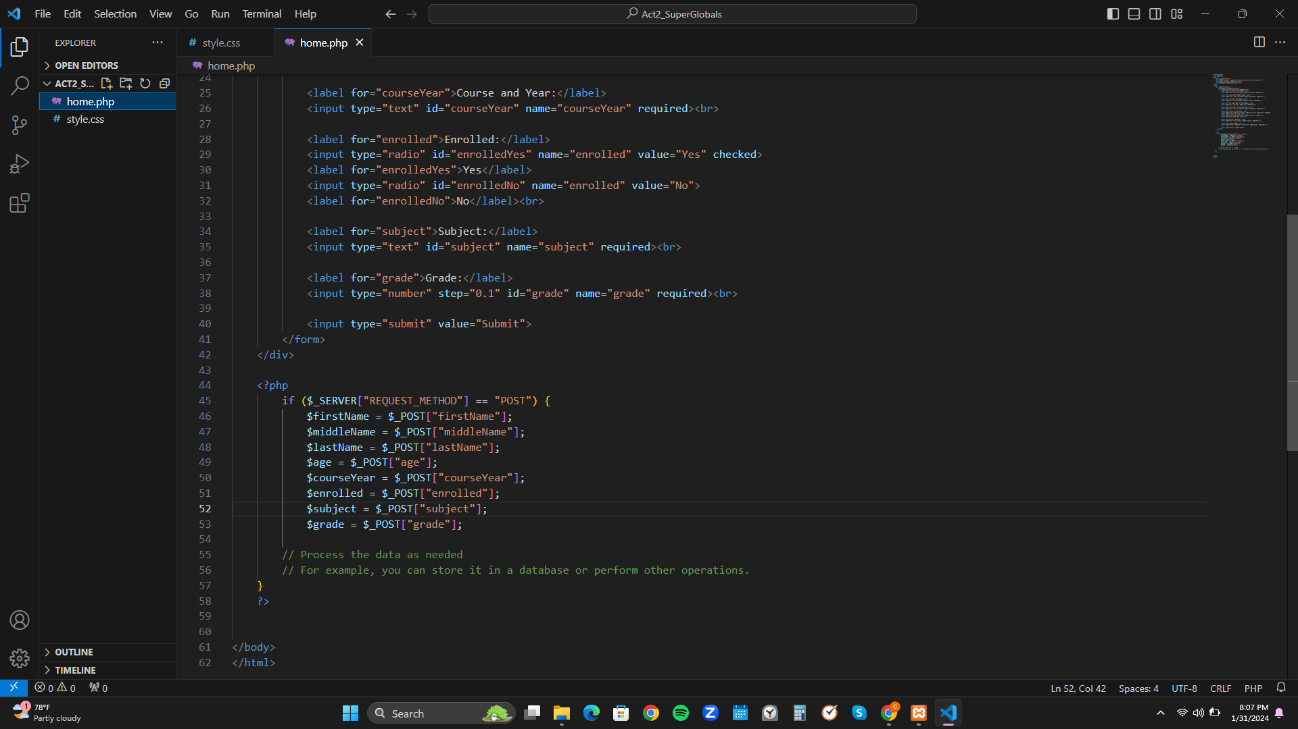

Style.css

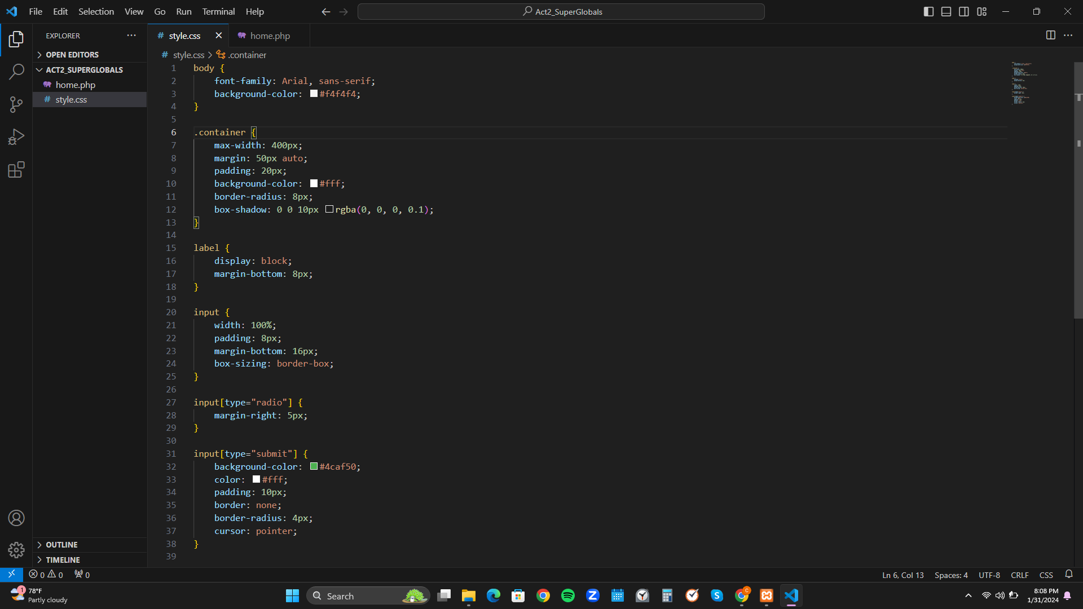

Output

